Numerical Solutions and Stability Analysis of the Solow Growth Model: A Comparative Study of Euler and Runge-Kutta Methods
Saleem Sulyman
November 2026
Abstract
The Solow growth model reduces to a single nonlinear differential equation for capital per effective worker. Under Cobb-Douglas production, this equation has a closed-form solution, which makes it a clean test case for numerical methods. This study compares the Euler, Heun (second-order Runge-Kutta) and classical fourth-order Runge-Kutta (RK4) methods on the Solow model calibrated to Nigeria for 1990 to 2023, using World Bank and Penn World Table data. Measured against the exact solution, the three methods converge at orders of 1.00, 2.00 and 3.97 respectively. With a one-year step, the maximum error is 5.0 × 10⁻² for Euler and 1.9 × 10⁻⁸ for RK4. Linearising the model at the steady state gives a convergence speed of 0.0237 per year, which places the stability limit of Euler and Heun at about 84 years and that of RK4 at about 116 years. Under a textbook capital share of 0.33, these limits fall to about 39 and 54 years. For this model, accuracy rather than stability is the practical concern at ordinary step sizes.
Keywords: Solow growth model; Euler method; Runge-Kutta methods; numerical stability; Nigeria

1. Introduction
The Solow-Swan model remains a standard framework for studying capital accumulation and convergence (Solow, 1956; Swan, 1956). Its dynamics reduce to one differential equation in capital per effective worker, and empirical work has long used its convergence property to study differences in income across countries (Mankiw et al., 1992).
Differential equations of this kind are usually solved on a computer in discrete time steps, and the choice of method and step size affects both accuracy and stability (Hairer et al., 1993; Judd, 1998). Judging a method is difficult when the true solution is unknown. The Solow model with Cobb-Douglas production is a helpful exception, because it can be solved exactly, so every numerical error can be measured directly.
Nigeria offers an informative case. Penn World Table data give a capital share of about 0.69, far above the textbook value of 0.33 (Feenstra et al., 2015). A high capital share slows convergence to the steady state, and this in turn changes how large a step each method can safely take.
This study therefore compares the Euler, Heun and RK4 methods on a Nigerian calibration of the Solow model. It measures their accuracy against the exact solution, derives and tests their stability limits, and contrasts the Nigerian case with the textbook one. The rest of the paper presents the model, the numerical methods, the data and calibration, the results, and the conclusion.

2. The Solow Model

2.1 Set-up
Output is produced with a Cobb-Douglas technology, Y = K^{α}(AL)^{1−α}, where K is capital, L is labour and A is the level of technology. Labour grows at rate n and technology at rate g. A constant share s of output is invested, and capital depreciates at rate δ. Writing k = K/(AL) for capital per effective worker, capital accumulation follows
dk/dt = s k^{α} − (n + δ + g) k (1)
The first term is new investment per effective worker. The second is the investment needed to replace worn-out capital and to equip new workers and new technology. This is the equation solved numerically in the rest of the paper.

2.2 Steady state
The economy settles where dk/dt = 0, which gives
k* = [ s / (n + δ + g) ]^{1/(1−α)} (2)

2.3 Exact solution
Equation (1) is nonlinear, but the substitution u = k^{1−α} turns it into a linear equation:
du/dt = (1 − α) s − λ u, λ = (1 − α)(n + δ + g) (3)
Its solution gives the exact path of capital:
k(t)^{1−α} = (k*)^{1−α} + [ k₀^{1−α} − (k*)^{1−α} ] e^{−λt} (4)
Equation (4) is the benchmark against which every numerical method is judged. It also shows that λ is the speed at which the economy closes its gap to the steady state, so the gap halves every ln(2)/λ years.

2.4 Local dynamics
Near the steady state, the slope of the right-hand side of (1) is
f′(k*) = α (n + δ + g) − (n + δ + g) = −λ (5)
So small deviations from k* behave like e′ = −λe. This linear form governs the stability of the numerical methods in Section 3.

3. Numerical Methods
Each method advances equation (1) from time t_{i} to t_{i+1} = t_{i} + h, where h is the step size and k_{i} is the computed value of capital at t_{i}. Write f(k) for the right-hand side of (1).

3.1 Euler method
k_{i+1} = k_{i} + h f(k_{i}) (6)
Euler uses one slope per step, taken at the start of the interval.

3.2 Heun method (RK2)
m₁ = f(k_{i}), m₂ = f(k_{i} + h m₁)
k_{i+1} = k_{i} + (h/2)(m₁ + m₂) (7)
Heun averages the slope at the start of the step with the slope at the point Euler would reach.

3.3 Classical Runge-Kutta method (RK4)
m₁ = f(k_{i}), m₂ = f(k_{i} + h m₁/2)
m₃ = f(k_{i} + h m₂/2), m₄ = f(k_{i} + h m₃)
k_{i+1} = k_{i} + (h/6)(m₁ + 2m₂ + 2m₃ + m₄) (8)
RK4 blends four slopes, giving the midpoint slopes double weight.

3.4 Accuracy
A method has order p if its global error shrinks in proportion to h^{p}. Euler has order 1, Heun order 2 and RK4 order 4. Halving the step should therefore cut the error by a factor of 2, 4 and 16 respectively. The order is estimated here as the slope of log error against log h.

3.5 Stability
Applying a method to the local equation e′ = −λe from Section 2.4 gives e_{i+1} = R(z) e_{i}, with z = hλ. The method is stable when |R(z)| < 1, with
Euler: R(z) = 1 − z
Heun: R(z) = 1 − z + z²/2
RK4: R(z) = 1 − z + z²/2 − z³/6 + z⁴/24
For Euler and Heun this holds when z < 2, so the largest stable step is h < 2/λ. For RK4 it holds when z < 2.785 (approximately), so h < 2.785/λ. For Euler, when 1 < z < 2 the error changes sign at every step while still shrinking.

3.6 Experimental design
Capital starts at k₀ = 0.2k* and is simulated over 100 years. Accuracy is measured as the maximum absolute difference from equation (4) across all steps, for h between 0.05 and 10 years. Stability limits are found by bisection: the largest h for which a simulation started at 0.9k* and run for 3,000 steps closes the gap to k* to less than 1 percent of its initial size. This is done for the Nigerian calibration and for a textbook case with α = 0.33.

4. Data and Calibration

4.1 Data sources
The model is calibrated to Nigeria for 1990 to 2023. Population growth comes from the World Bank’s World Development Indicators (annual population growth, converted from percent to a decimal). The investment share, the labour share and the depreciation rate come from the Penn World Table, version 11.0 (Feenstra et al., 2015). The World Bank series for gross capital formation contained no observations for Nigeria in the extract used here, so the Penn World Table’s share of gross capital formation in GDP serves as the investment share s. In the Solow model s is the share of output invested, which makes investment a closer match than saving for an open economy.
Population growth is available to 2025, but the Penn World Table ends in 2023, so all parameters are averaged over 1990 to 2023 to describe the same period.

4.2 Calibration
Each parameter is set to its average over the period. The capital share is α = 1 − (labour share). The technology growth rate g is not observed in these data and is fixed at 0.02, a value commonly used in the literature. Table 1 reports the values.
Table 1. Calibrated parameters for Nigeria, 1990 to 2023
Parameter | Symbol | Value | Source
Investment share | s | 0.2137 | Penn World Table (share of capital formation)
Capital share | α | 0.6879 | Penn World Table (1 − labour share)
Population growth | n | 0.0259 | World Development Indicators
Depreciation rate | δ | 0.0301 | Penn World Table
Technology growth | g | 0.0200 | Assumed
These values imply a steady state of k* = 27.40 and a convergence speed of λ = 0.0237 per year, so the gap to the steady state halves about every 29 years. For comparison, a textbook case uses α = 0.33 and the same remaining parameters.

4.3 Limitations of the calibration
Period averages hide year-to-year variation. The Penn World Table labour share is identical in every year from 2010 onward, which suggests it has been carried forward rather than newly measured. The value of g is an assumption and not an estimate. The initial condition, k₀ = 0.2k*, is a modelling choice that represents a capital-poor economy. None of these affects the comparison between methods, which depends on λ and the step size, but they do affect the economic interpretation of the Nigerian path.

5. Results

5.1 Accuracy
Table 2 reports the maximum absolute error against the exact solution (4), and Figure 2 plots it on a log-log scale.
Table 2. Maximum absolute error by step size
h (years) | Euler | Heun | RK4
0.05 | 2.50 × 10⁻³ | 1.51 × 10⁻⁶ | 1.35 × 10⁻¹³
0.25 | 1.25 × 10⁻² | 3.77 × 10⁻⁵ | 7.53 × 10⁻¹¹
1 | 5.02 × 10⁻² | 6.07 × 10⁻⁴ | 1.92 × 10⁻⁸
2 | 1.01 × 10⁻¹ | 2.45 × 10⁻³ | 3.04 × 10⁻⁷
5 | 2.54 × 10⁻¹ | 1.56 × 10⁻² | 1.15 × 10⁻⁵
10 | 5.16 × 10⁻¹ | 6.46 × 10⁻² | 1.75 × 10⁻⁴
The fitted orders of convergence are 1.00 for Euler, 2.00 for Heun and 3.97 for RK4, which agree with theory. The RK4 estimate sits slightly under 4, and at the smallest steps its error of about 10⁻¹³ is consistent with rounding error starting to matter.
With a one-year step, which suits annual data, Euler’s error is about 0.05, roughly 0.2 percent of the steady-state level of 27.40. Heun’s error is about 80 times smaller and RK4’s is more than a million times smaller than Euler’s. Extrapolating Euler’s first-order error, it would need a step of about 4 × 10⁻⁷ years to match RK4 at h = 1. Figure 1 shows the same pattern at a coarse step of 10 years: Euler drifts above the exact path while Heun and RK4 are visually indistinguishable from it.
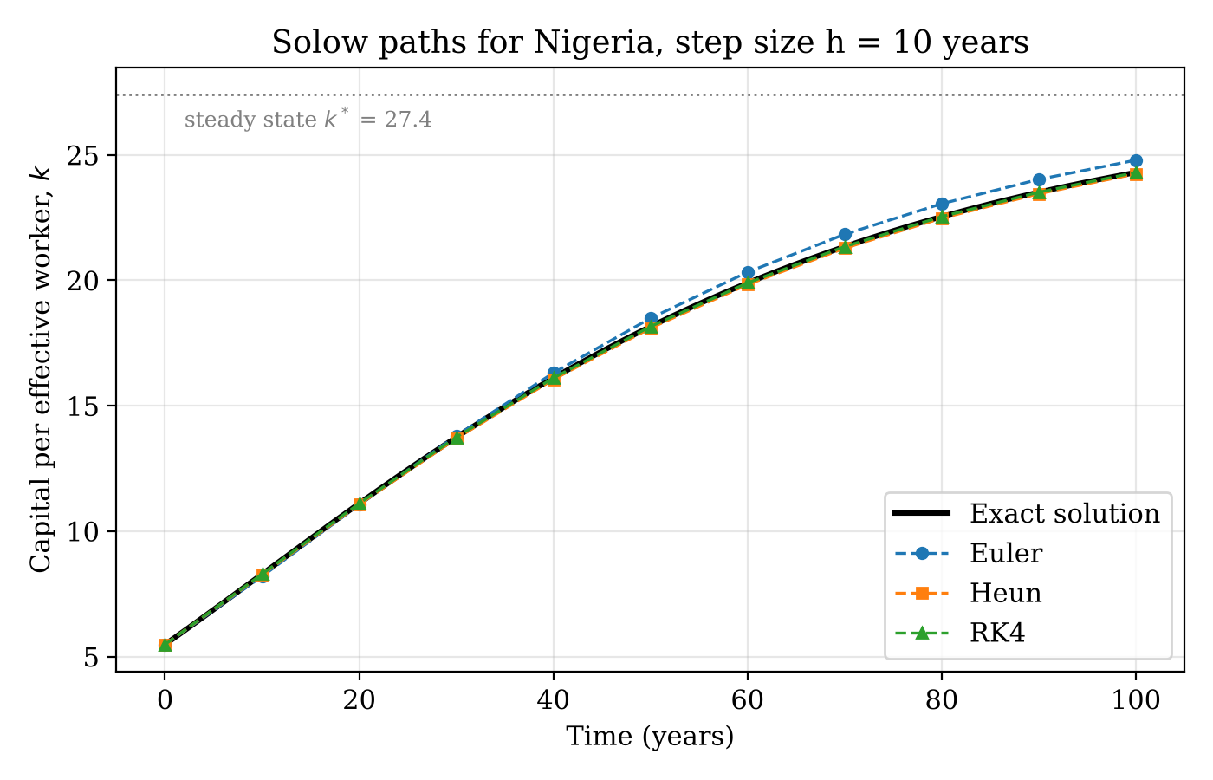
Figure 1. Solow paths for Nigeria computed with a step size of 10 years
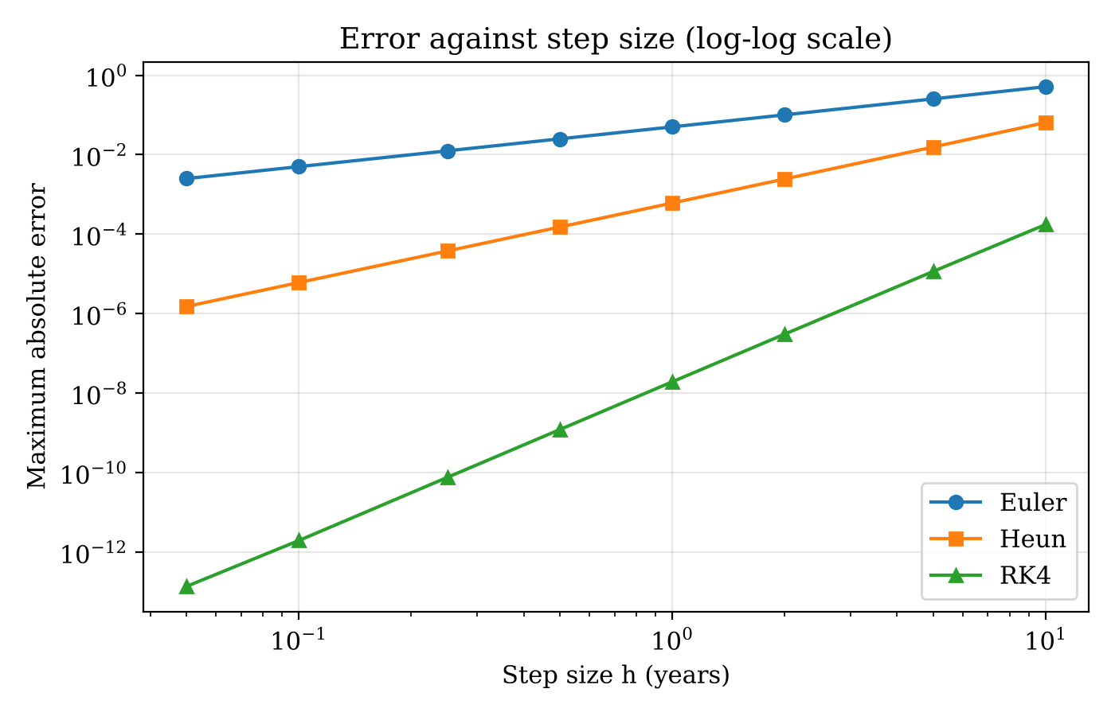
Figure 2. Maximum absolute error against step size (log-log scale)

5.2 Stability
Table 3. Largest stable step size (years)
Case | α | λ | Euler | Heun | RK4
Nigeria | 0.688 | 0.0237 | 84.2 | 84.2 | 116.3
Textbook | 0.330 | 0.0509 | 39.2 | 39.2 | 54.4
The simulated limits agree closely with the theory of Section 3.5, which gives 84.3 years for Euler and Heun and about 117 years for RK4 in the Nigerian case. The small shortfall for RK4 likely reflects the finite test horizon, because convergence is very slow close to the boundary, and the nonlinearity of the full model. Heun shares Euler’s limit, so higher accuracy does not buy a larger stable step, while RK4 extends the limit by about 38 percent.
Figure 3 shows the three regimes for Euler in the Nigerian case. At hλ = 0.5 the gap decays smoothly, at hλ = 1.5 it oscillates but decays, and at hλ = 2.5 it oscillates with growing amplitude.
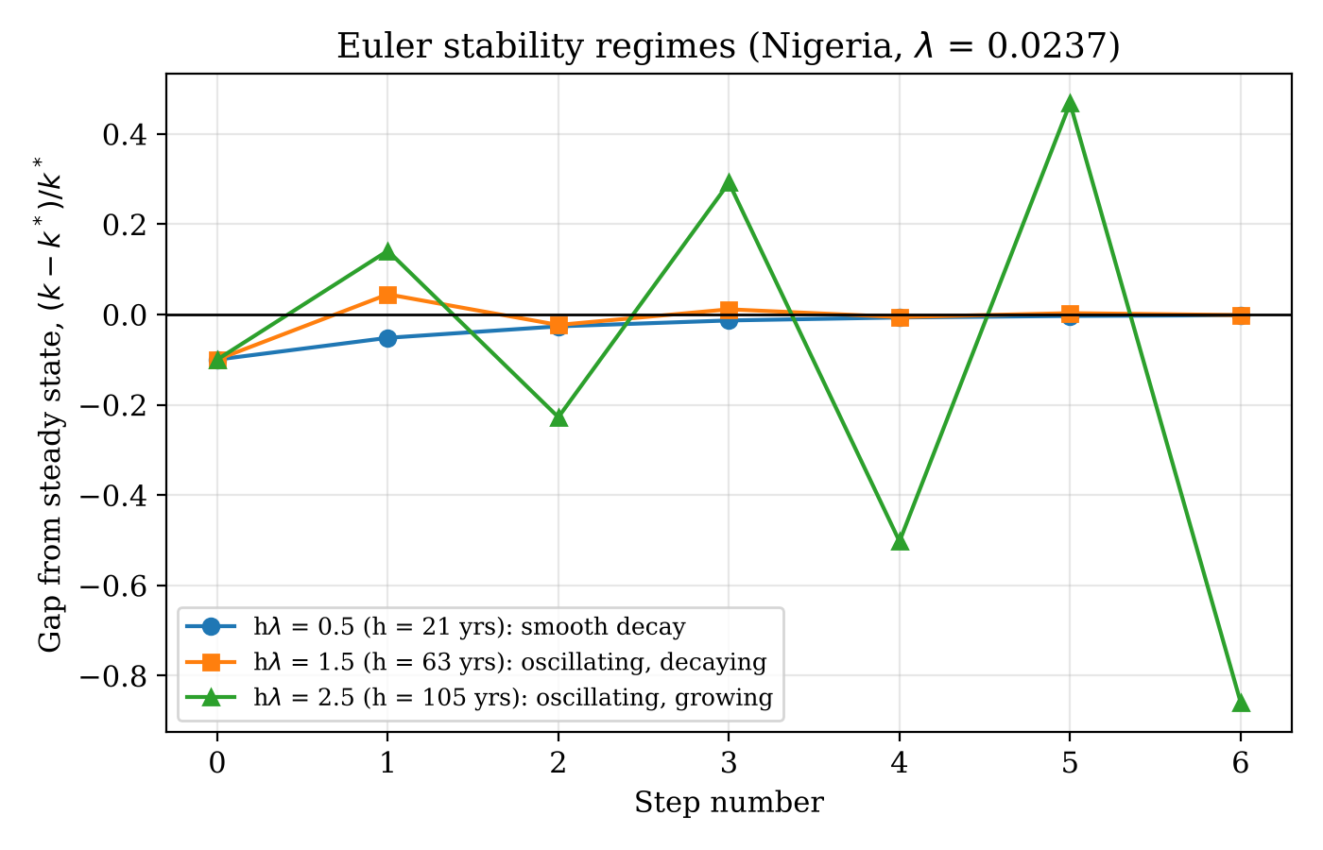
Figure 3. Euler stability regimes for the Nigerian calibration

5.3 Nigeria compared with the textbook case
The high Nigerian capital share lowers λ from 0.0509 to 0.0237, so every stability limit roughly doubles. Slower convergence therefore makes the model easier to solve safely, and the Nigerian limits, above 80 years, lie far outside any step used in practice.

6. Conclusion
This study compared the Euler, Heun and RK4 methods on the Solow growth model calibrated to Nigeria for 1990 to 2023. Because the Cobb-Douglas model has a closed-form solution, each method’s error could be measured exactly. The methods converged at orders of 1.00, 2.00 and 3.97, in line with theory. At a one-year step, RK4 was more than a million times more accurate than Euler, and Heun about 80 times more accurate.
The stability analysis showed that the largest stable step is set by the convergence speed λ of the model. For Nigeria, λ = 0.0237 gives limits of about 84 years for Euler and Heun and 116 years for RK4. A textbook capital share of 0.33 roughly halves these limits. In practice, then, the choice of method for this model is driven by accuracy and not by stability.
Three limitations apply. The calibration uses period averages, the technology growth rate is assumed, and the Penn World Table labour share appears to be carried forward after 2010. Future work could test sub-period calibrations, other production functions without closed-form solutions, and adaptive step-size methods.

Data and Code Availability
All code, data and results are openly available at https://github.com/sulymansaleem04-source/solow-numerical-methods and are archived on Zenodo (DOI: [TO BE ADDED AFTER RELEASE]). Running run_all.py reproduces every table and figure in this paper.

References
Feenstra, R. C., Inklaar, R., & Timmer, M. P. (2015). The next generation of the Penn World Table. American Economic Review, 105(10), 3150–3182. https://doi.org/10.1257/aer.20130954
Groningen Growth and Development Centre. (2025). Penn World Table version 11.0 [Data set]. University of Groningen. https://doi.org/10.34894/FABVLR
Hairer, E., Nørsett, S. P., & Wanner, G. (1993). Solving ordinary differential equations I: Nonstiff problems (2nd rev. ed.). Springer.
Judd, K. L. (1998). Numerical methods in economics. MIT Press.
Mankiw, N. G., Romer, D., & Weil, D. N. (1992). A contribution to the empirics of economic growth. The Quarterly Journal of Economics, 107(2), 407–437. https://doi.org/10.2307/2118477
Solow, R. M. (1956). A contribution to the theory of economic growth. The Quarterly Journal of Economics, 70(1), 65–94. https://doi.org/10.2307/1884513
Swan, T. W. (1956). Economic growth and capital accumulation. Economic Record, 32(2), 334–361. https://doi.org/10.1111/j.1475-4932.1956.tb00434.x
World Bank. (n.d.). World Development Indicators [Data set]. https://databank.worldbank.org/source/world-development-indicators

